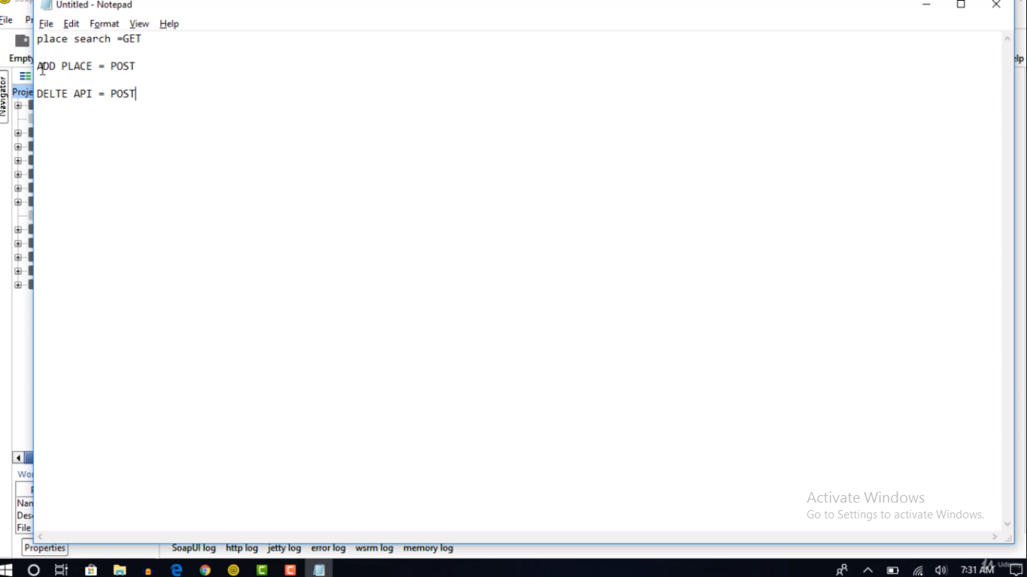

* POST is superset of PUT and DELETE. So we can use POST in place of them.
* Now we will test Rest api using SOAP ui and Restful services created by Rahul Shetty.
* Go to soap ui and click here

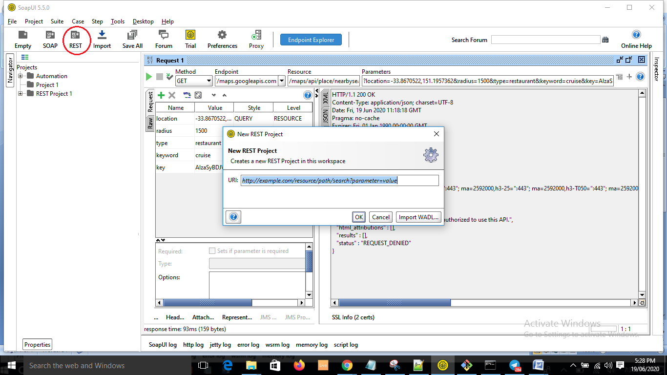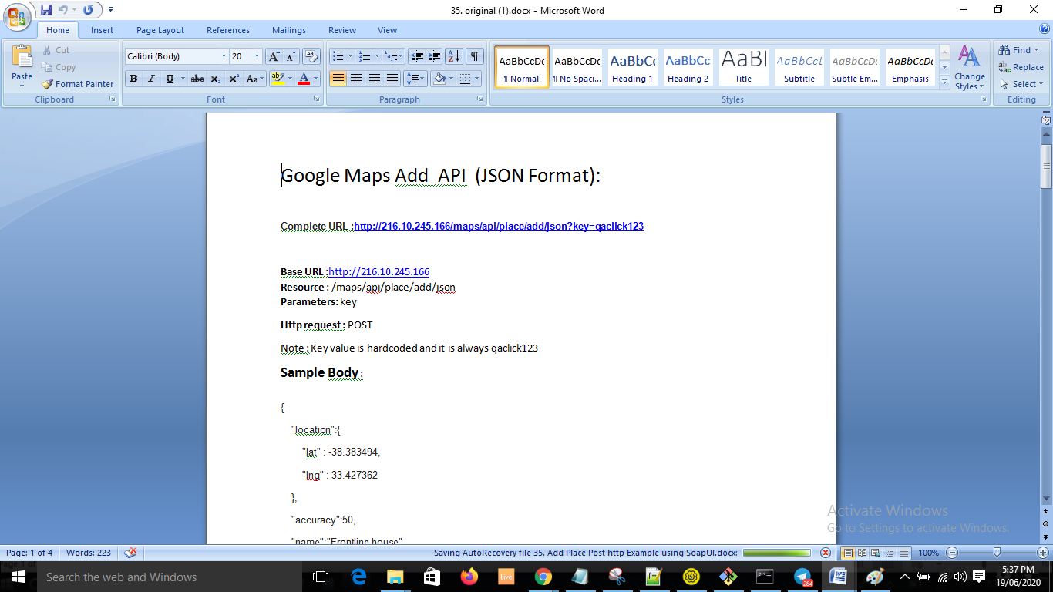

* Enter only base url > ok

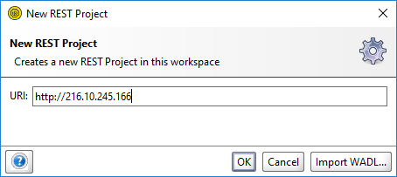

* Change method to POST.

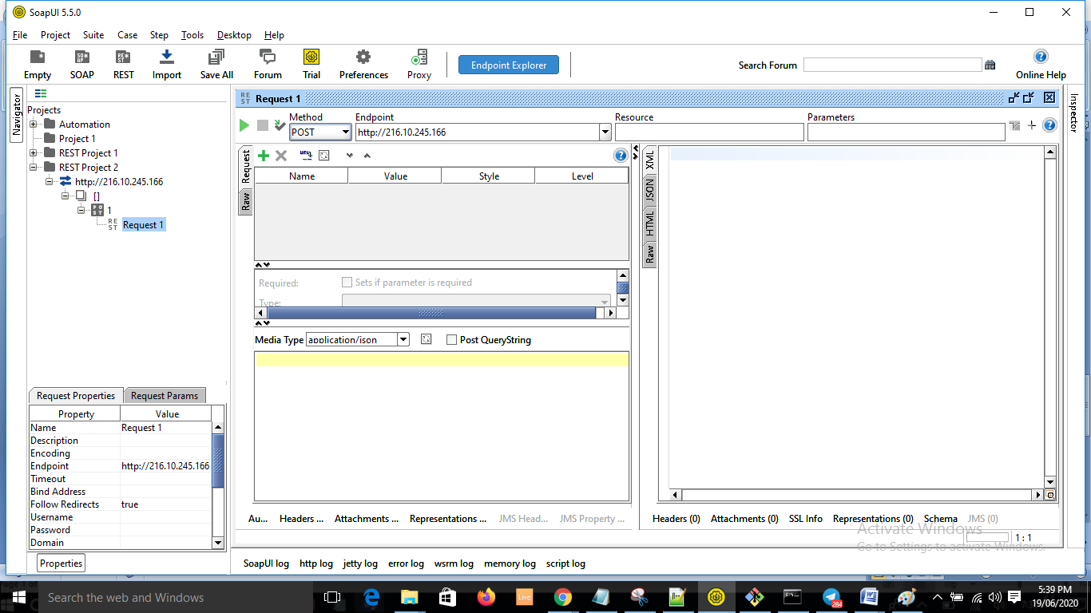

* Now we need to add resources. We can directly add resources here.



Or else:

Right click on the base URI > New Resource.

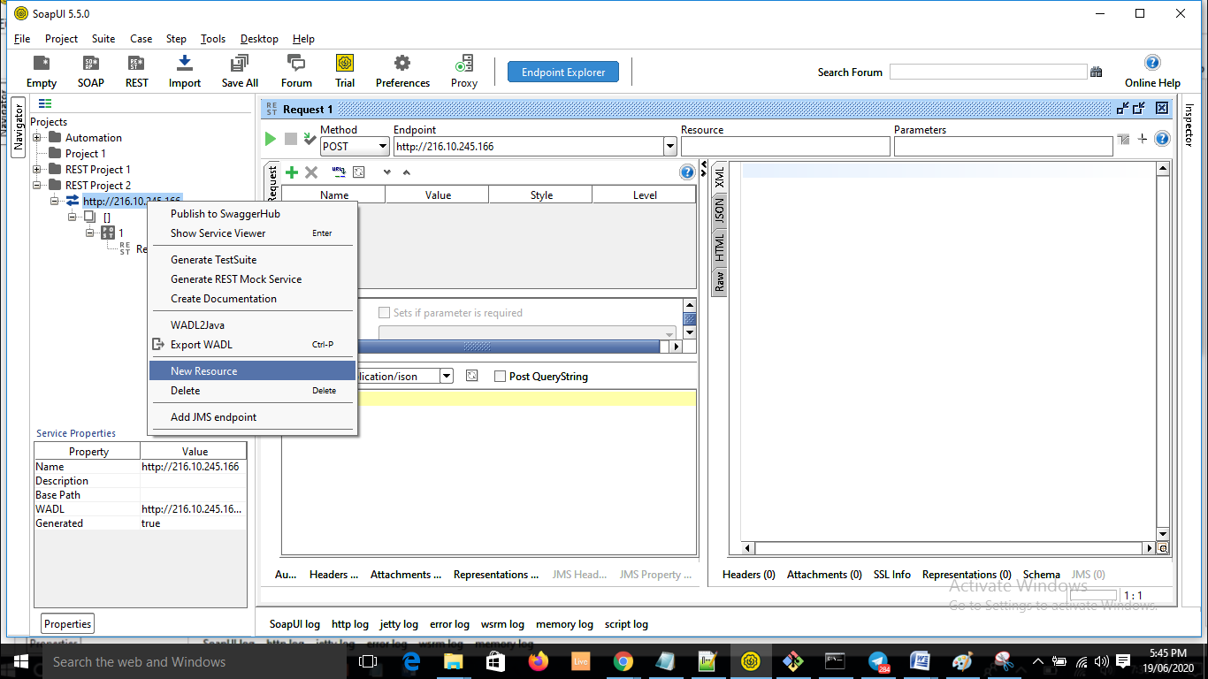

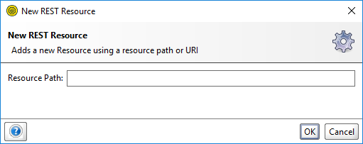

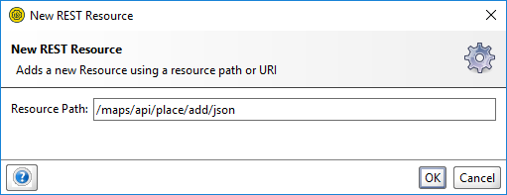

* Click OK.
* Click yes.

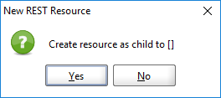

* We need to pass the key now. It has been harcoded to qaclick123.
* Provide the key details in parameters.
* Click on Parameters:

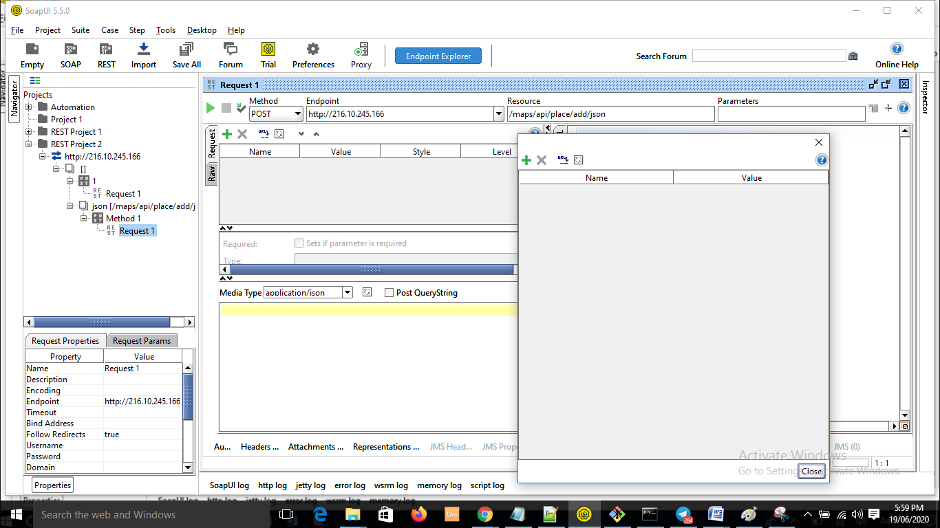

* Click Add.
* Enter params.

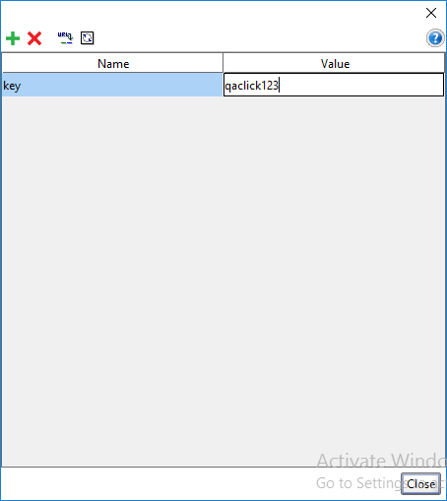

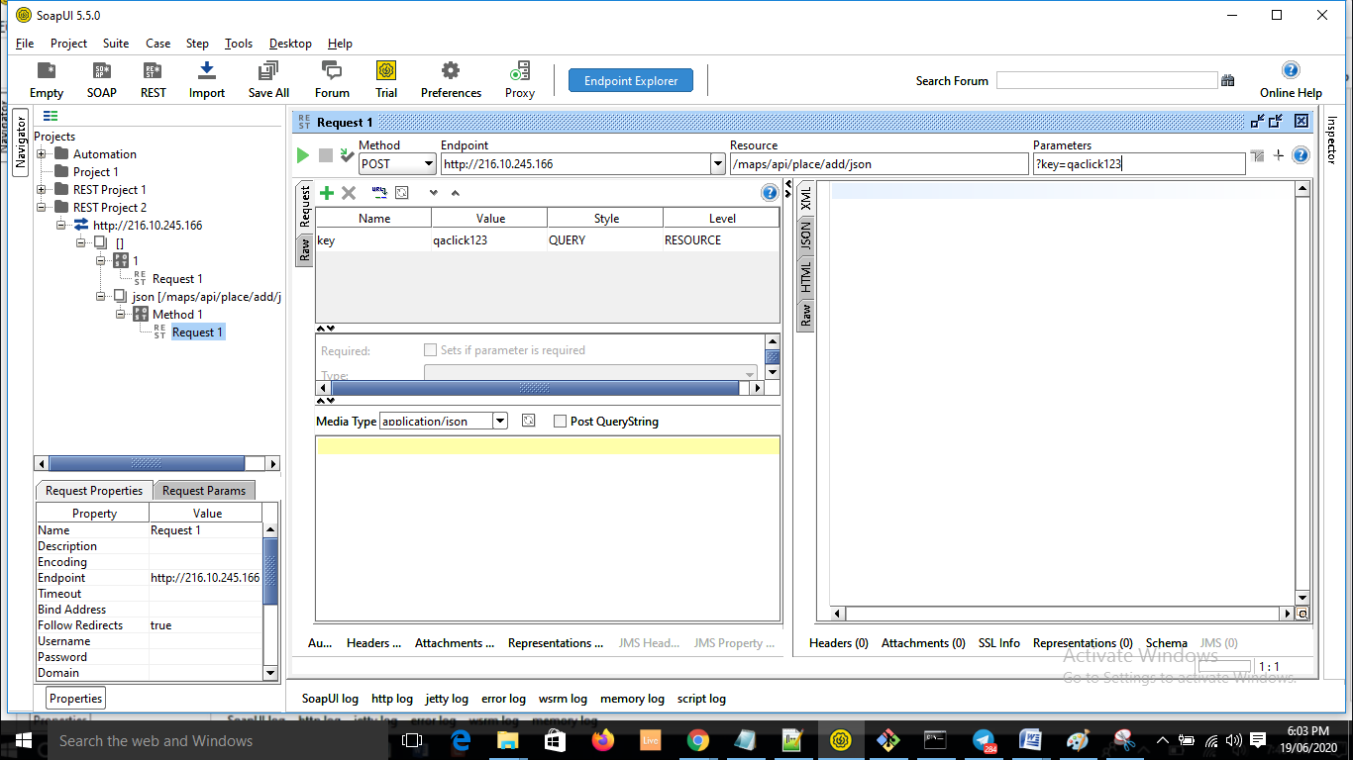

* If we add the parameter to the uri itself, then it is known as query parameter.
* Now add the body. This body needs to be sent securely.

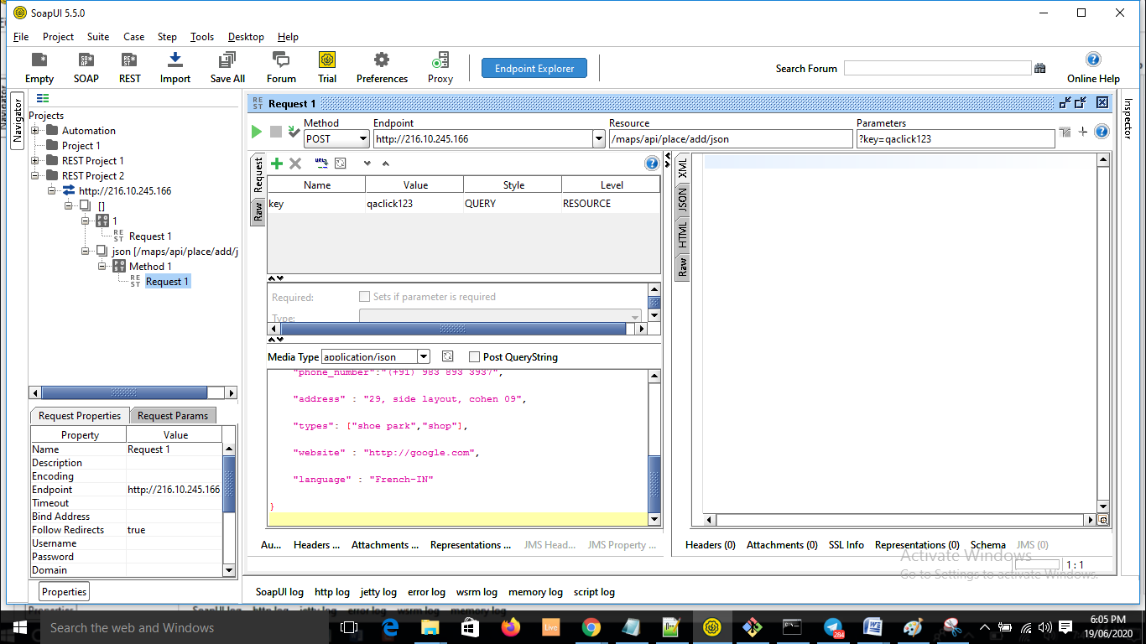

* Now submit.

